# Christmas Cheer Laser, part 1

The terminal we need is in the Holiday Hack Challenge Game <https://holidayhackchallenge.com/2019/> The terminal is in the laboratory in Hermey Hall, next to Sparkle Redberry.

Sparkle asks us to correct the settings on his Christmas Cheer Laser and tells us that we will need to use PowerShell. He even gives us the link to a PowerShell cheat sheet.  
<https://blogs.sans.org/pen-testing/files/2016/05/PowerShellCheatSheet_v41.pdf>

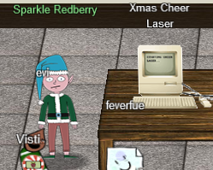

## Getting started

Connect to the terminal and read its opening instructions. You will find the path for a taunting note the attacker left, and instructions on how to access the laser’s Web API.

# Questions

1. Read the attacker’s taunting note. What command would access the data he suggests we look at?
2. Use the PowerShell command for getting a web page, Invoke-WebRequest, to see the status of the laser (the command is in red in the laser terminal.) What parameters will we have to find to correctly calibrate the laser? Hint: one of them is lens refraction, or refraction.